UNICEF Data For bullying

%age of students aged 13-15 years, who reported being bullied on one or more days in the past 30 days

41% of students in Pakistan aged 13-15 have reported being bullied at school

In Pakistan, a male student aged 13-15 is 30% more likely to report a bully crime vs a female student

35% of Female students aged 13 – 15 in Pakistan have reported being bullied for one or more days in the past 30 days

**📊 The Big Picture**

* **Global Average:** About 30% of children worldwide experience bullying
* **Gender Gap:** Boys face slightly more bullying than girls (31.2% vs 29.4%)
* **Huge Variation:** Some countries have rates as low as 15%, others as high as 50%+

We deep dive into the dataset and find a consistent bullying pattern across countries regardless of their GDP per capita and Education spending. This highlights bullying as a global problem. High-income countries do not consistently show lower bullying. Some (e.g., Australia, Canada, New Zealand) have high rates, possibly due to better reporting. US has a reported bullying rate of 26% despite a $1.3 trillion Education budget

* **Mean vs Median:** The average (30.4%) is higher than the middle value (27.4%), suggesting some countries have very high rates that pull the average up
* **Male Variation:** Boys' bullying rates vary more dramatically between countries - some places might have cultural or social factors that particularly affect boys

Europe & Central Asia: Female students aged 13-15 are more likely to report a bully crime

Middle East: More male students have reported being bullied at school

* **Standard Deviation (~12):** This means most countries fall within about 18-42% bullying rates (one standard deviation from the mean)

These statistics reveal that bullying is a significant global issue affecting roughly 1 in 3 children. The variation between countries suggests that cultural, policy, and educational factors can make a real difference in reducing bullying rates.

57 countries had no data available

Notably INDIA & China along with i.e Sudan, Ethiopia, Zimbabwe, Nigera,

Country with Lowest Female Bullying = Malaysia – 8% of female students reported being bullied

Country with Lowest Male Bullying = Malaysia – 9.1% of male students reported being bullied

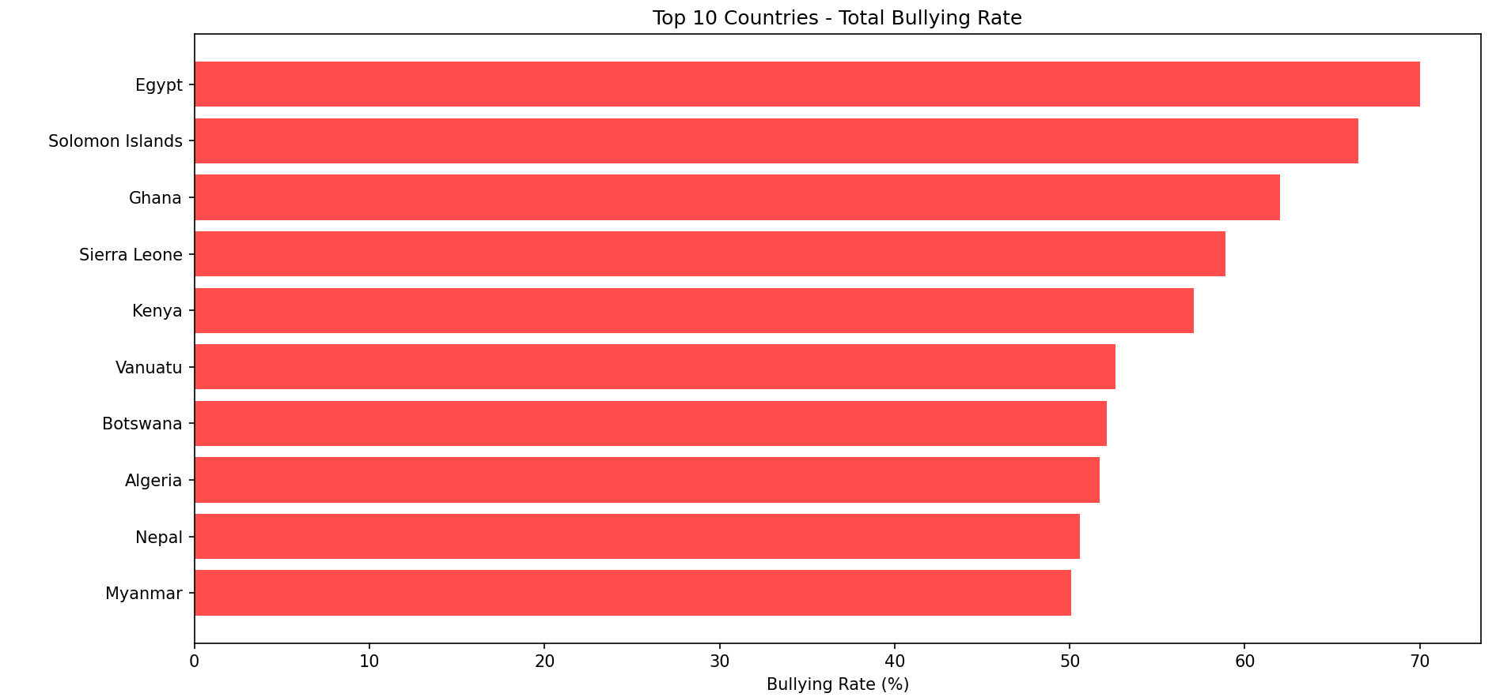

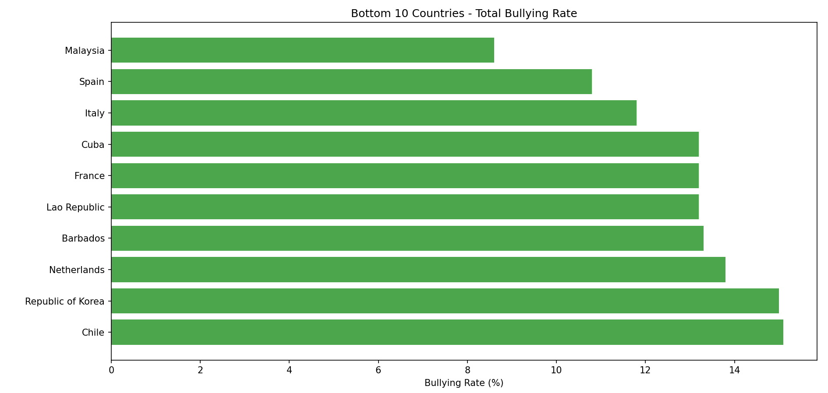

We extend the analysis towards understanding GDP per capita of countries and reported bullying rates.

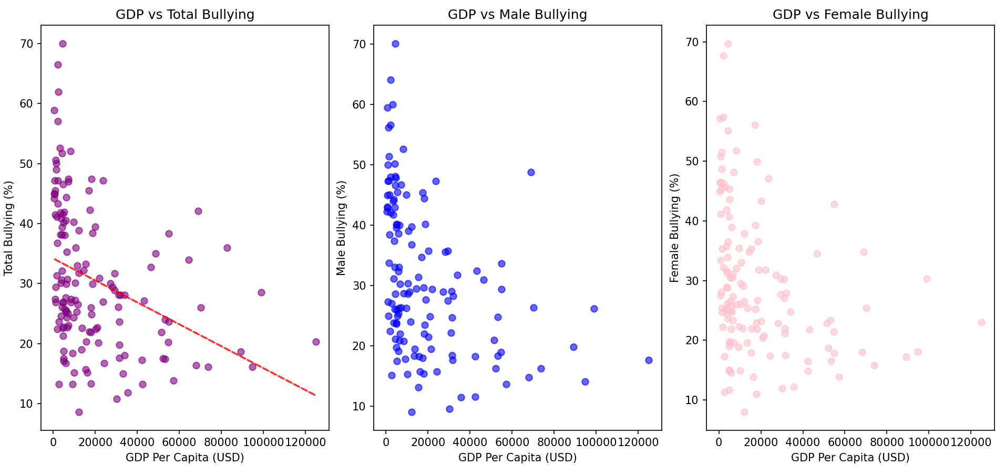

GDP vs Bullying: Likely weak or no strong negative correlation. High GDP per capita doesn’t always mean lower bullying

Poverty Rates:

We compare poverty rates across countries vs reported bullying rates: May show positive correlation, especially in Sub-Saharan Africa and South Asia.

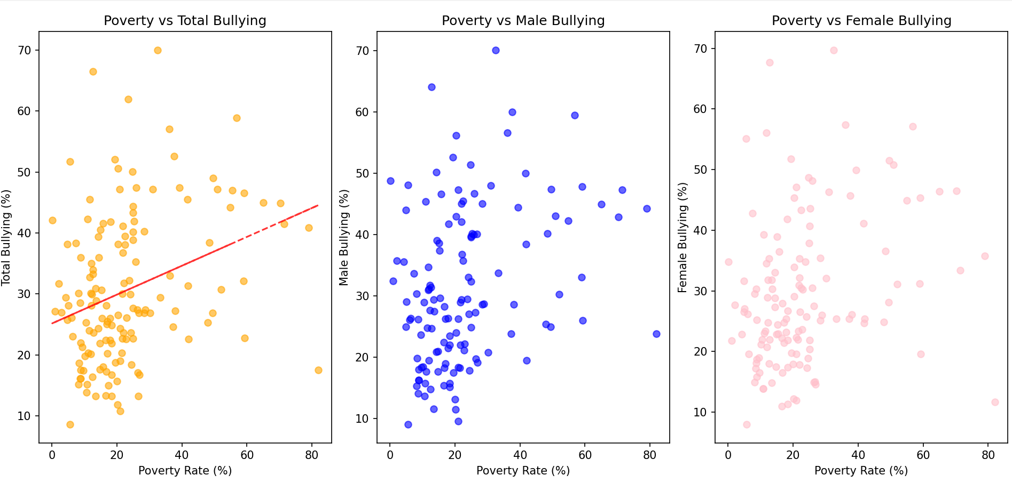

We compare education spending (% age of GDP) for each country vs reported bullying rates to test if higher education spending was effective in preventing bullying

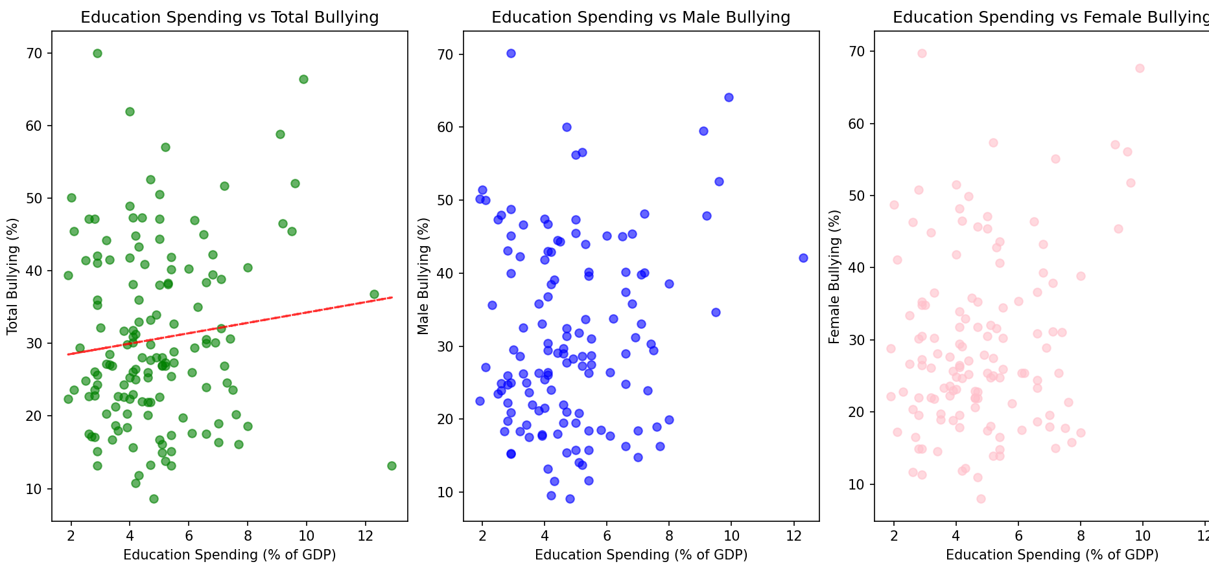

We couldn’t establish the pattern here and will need to deep dive even further

We categorize countries across different tiers based on GDP per Capita as:

High Income (Notable names: US, UK, UAE, KSA, Qatar, Japan, Italy, Israel)

Upper Middle Income (Brazil, Indonesia, Iraq, Malasyia, Maldives, Mexico)

Lower Middle Income (Bangladesh, Egypt, Pakistan, Nepal, Philippines)

Low income (Yemen, Uganda)

and try to understand distributions across these tiers

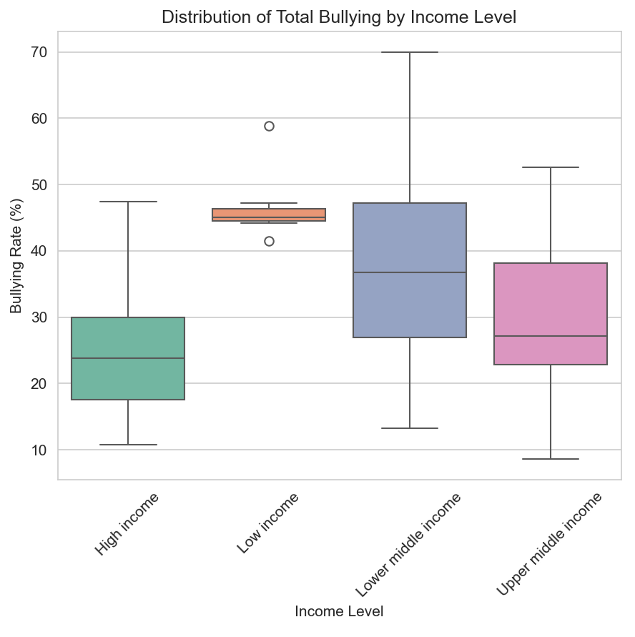

* **Lower middle income countries**: These have wide variation in bullying, with some countries showing quite high rates, but others much lower.
* **High income countries**:do not necessarily showing low levels of bullying, still have high rates, possibly due to availability and easy accessibility of better reporting mechanisms

Bully Rates

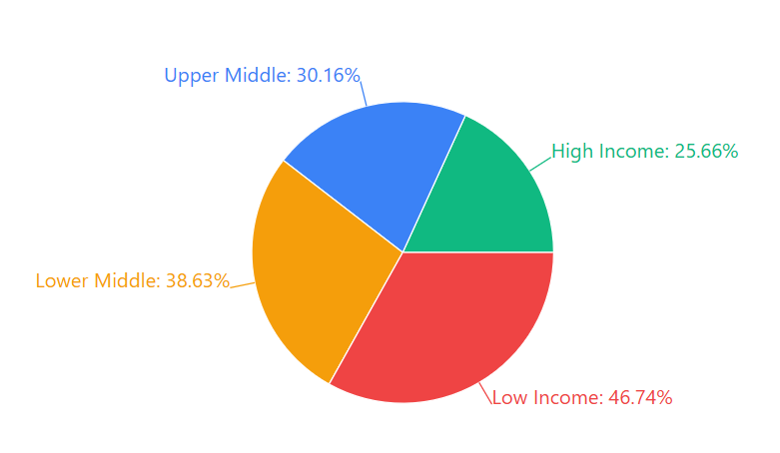

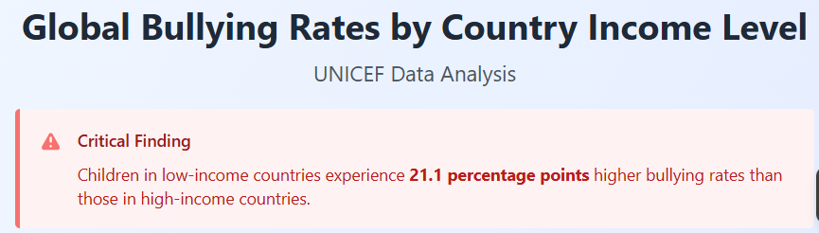

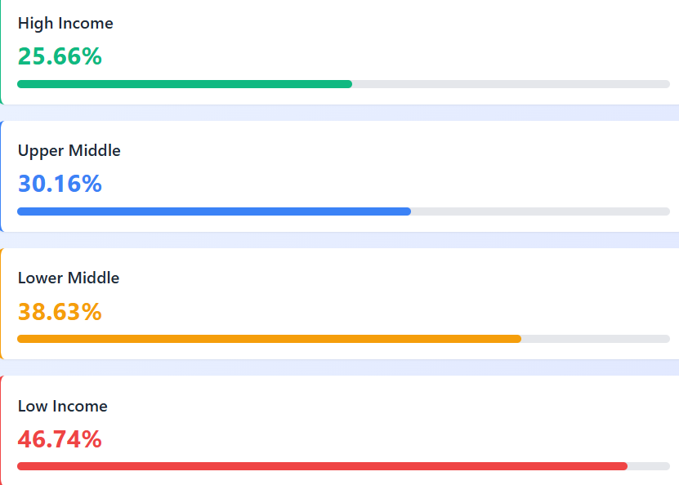

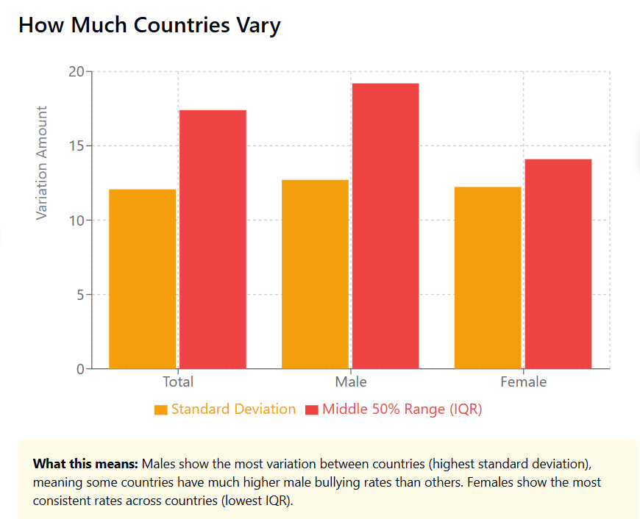

**Interquartile Range (IQR)**: This shows the range where the middle 50% of countries fall. For total bullying, this spans 17.4 percentage points (22% to 39.4%).